Autism and STEM: Fostering Balanced and Inclusive Communities at School and at Work

For autistic high school and college students, and those who support them. This conference will explore the skills and resources needed for collegiate and workplace success, including considerations such as self-advocacy, internal motivation, and organizational and executive functioning abilities. Environmental resources for educational and workplace professionals will also be explored, including understanding autistic culture and communication, and the value of a neurodiverse workplace. Bellevue College STEM faculty will share best practices and Bellevue College STEM students will discuss the college experience. A professional panel from Microsoft’s Autism community will talk about career experiences. Hosted by Stairway to STEM (STS) in collaboration with Bellevue College’s RISE Learning Institute and Autism Spectrum Navigators Program.

Saturday, May 11, 2019; Venue: Bellevue College, N201

9:15 – 10:00 am Check-in – receive your name badge and conference materials

10:00 – 10:15 am Opening remarks: Bellevue College

10:15 – 11:00 am Presentation: Sara Sanders Gardner and Patrick Dwyer: Preparing for Academic and Professional Success

11:00 – 11:15 am Break

11:15 – 12:00 Panel: STEM Faculty, Bellevue College – focus on Best Practices for teaching autistic STEM College students, with advice for faculty & students

12:00 – 1:15 pm Lunch included with your registration

1:15 – 2:00 pm Panel: STEM Students, Bellevue College – discuss how college differs from high school, how to advocate for yourself in college, preparing for college. See prepared questions.

2:00 – 2:15 pm Break

2:15 – 3:15 pm Panel: Microsoft Autism Community Employees – members of the community will share what they have learned about self-advocacy, internal motivation, and accommodations in the workplace.

3:15 – 3:30 pm Break and Q & A, Microsoft and any panel members still on site from previous panels

3:30 – 4:00 pm Closing Remarks: Stairway to STEM

Presenter and Speaker Bios

Patrick Dwyer | 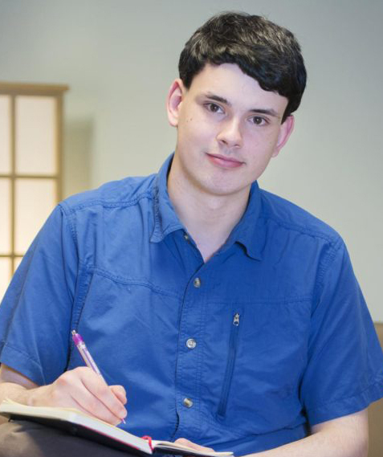 | Patrick is an autistic graduate student in the psychology department at UC Davis with a broad interest in helping to ensure that autistic and neurodivergent people can lead fulfilling lives. He plans to use eye-tracking and electrophysiology to explore the heterogeneity of the autism spectrum and different phenotypes of autism, and is particularly interested in studying sensory processing and sensory sensitivities in autism. He has also facilitated peer-support groups for other autistic college students. You can find more of Patrick’s writing on his blog at autisticscholar.com, and he is a frequent guest contributor to Stairway to STEM.
Sara Sanders Gardner | 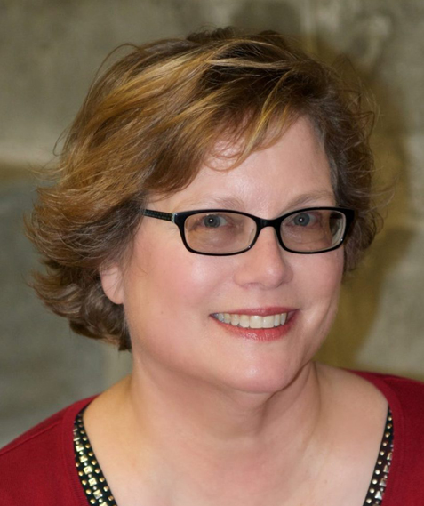 | Sara is an autistic professional living in Redmond, Washington, near Seattle. Sara is the designer and Program Director of Bellevue College’s Autism Spectrum Navigators program, now in its 8th year, serving over 200 students. Sara also consults with Microsoft’s U.S. Autism Inclusive Hiring program, and leads training sessions with prospective managers and team peers of individuals hired through the program – discussing areas such as social justice, autism as a culture and a disability, and communication styles. Sara serves on the Editorial Board at Stairway to STEM.
Jessica Murray | 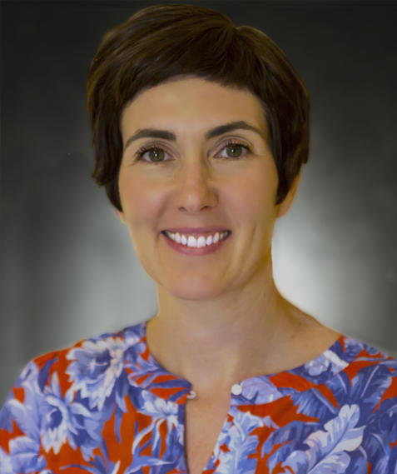 | Jessica is the Managing Editor for Stairway to STEM (STS). Jessica has worked in the higher ed., nonprofit, and publishing sectors since 2004. She’s in charge of the day-to-day operations for STS. She has learned a lot about autistic culture and the needs of students, families, and educators from working on STS, which has been an incredibly rewarding and enriching experience. Hitting publish on an impactful piece of content, which came together through truly collective processes, makes her day.

